The PDF is organized as follows (links are clickable to aid navigation):

* Classes
  + Symbol
  + SymbolTable
  + QuadTable
  + ReserveTable
* Main
* Functions
  + InterpretQuads
  + BuildQuads
  + BuildSymbolTable
* Output
  + Factorial(10) with trace
  + Factorial(10) without trace
  + Summation(10) with trace
  + Summation(10) without trace

**Class****es**

**Cla****ss Symbol**

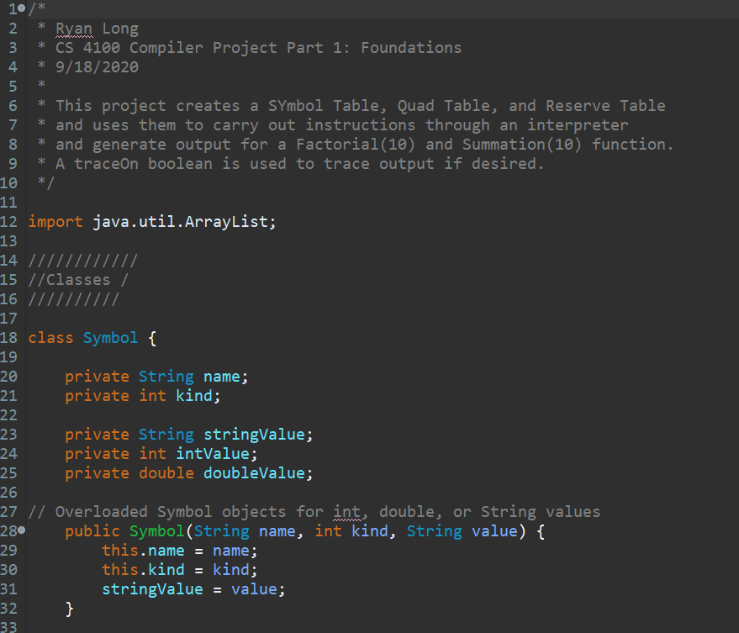

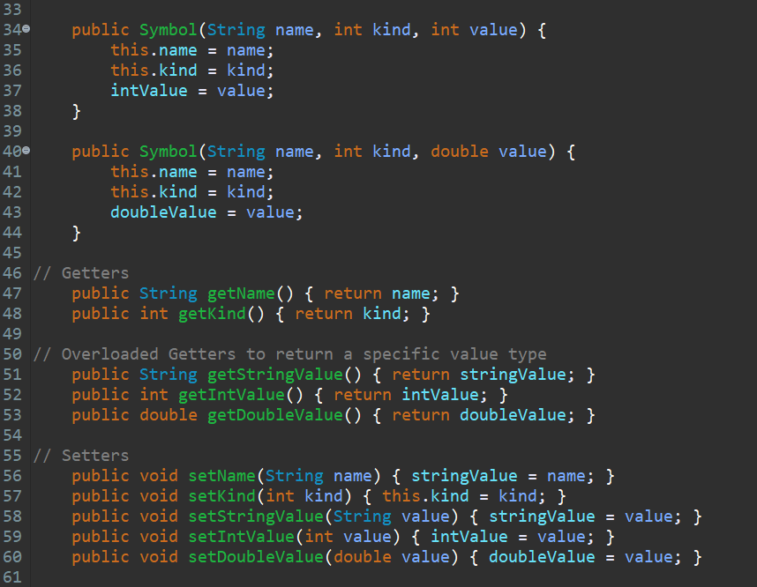

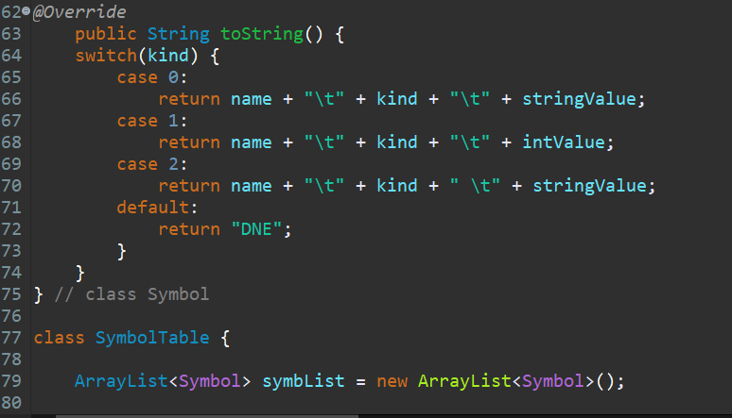

**Class Symb****olTable**

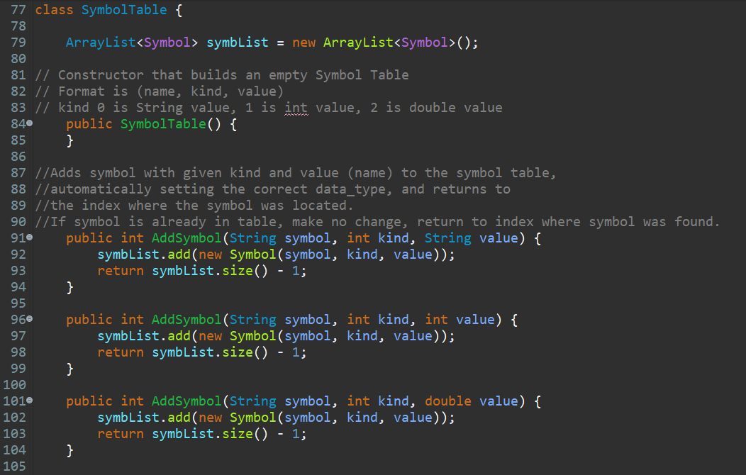

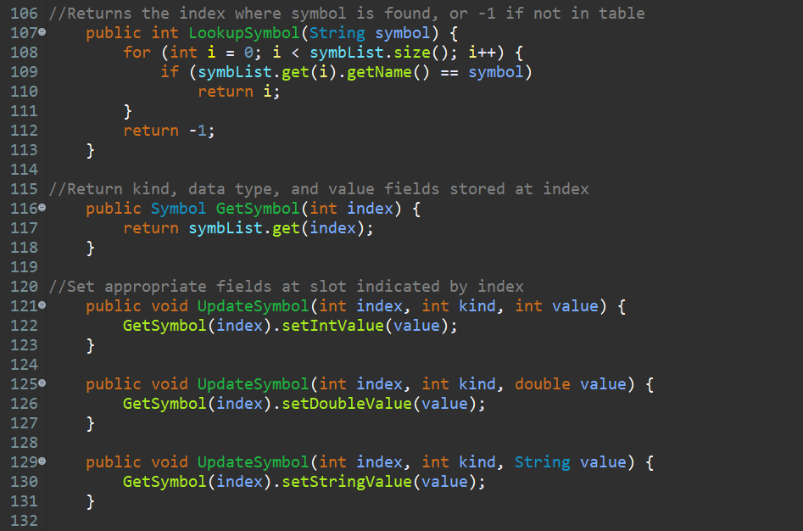

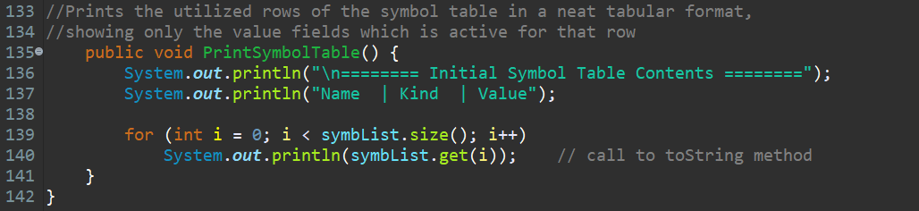

**Class QuadT****able**

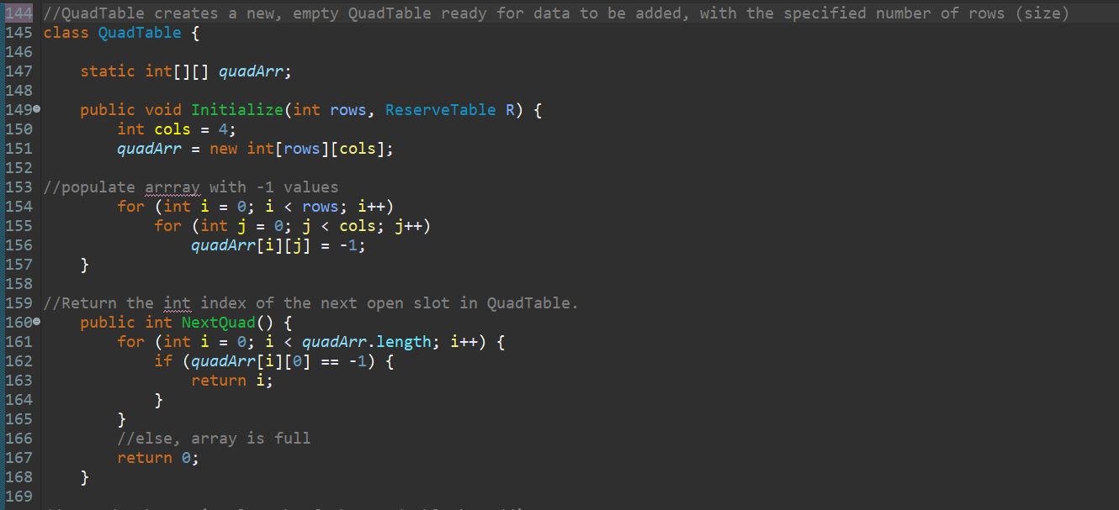

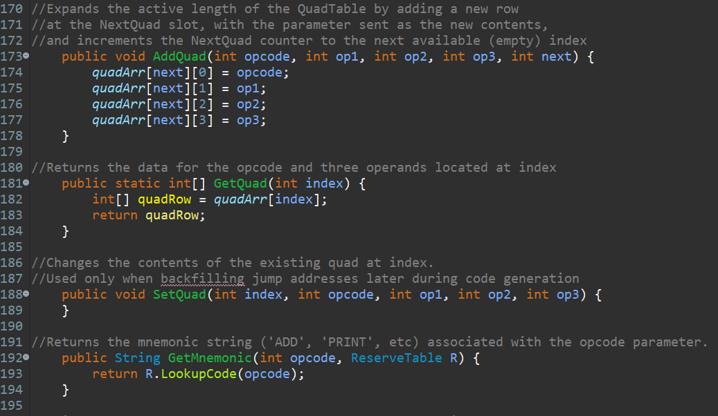

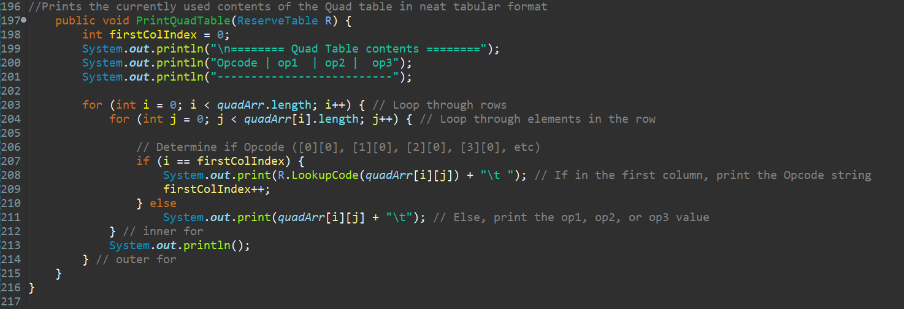

**Class Re****serveTable**

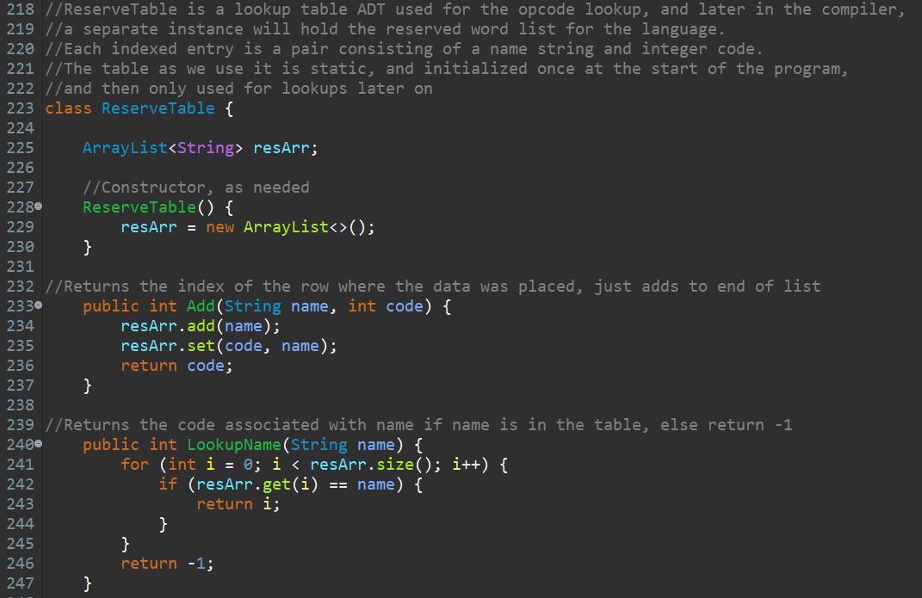

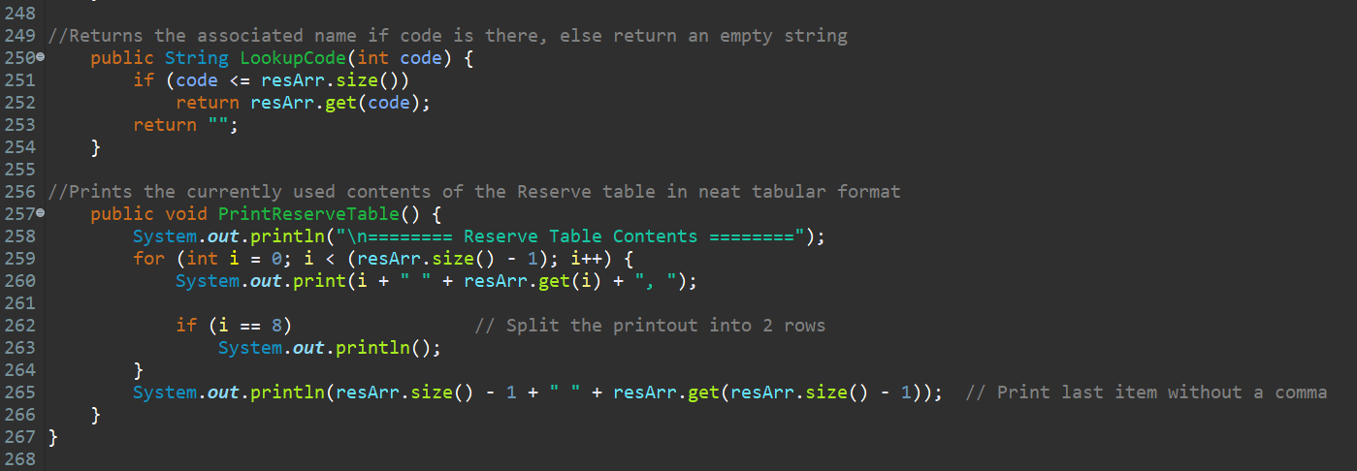

**M****ain**

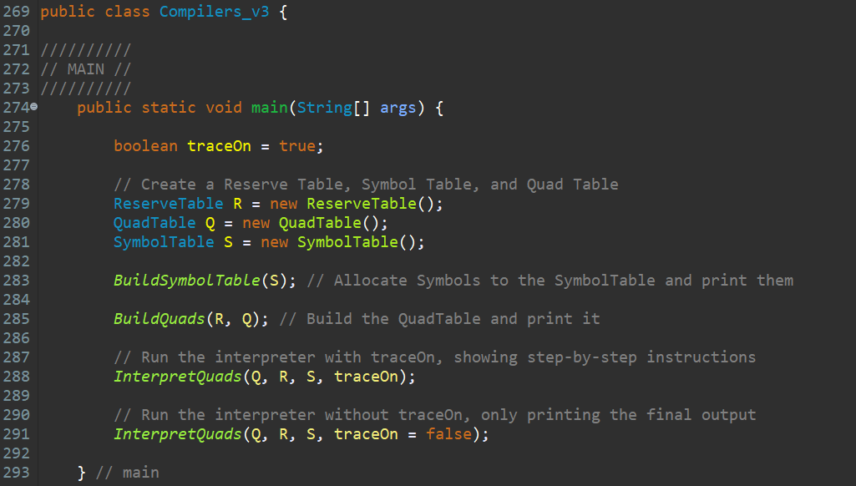

**Func****tions**

**Interpr****etQuads**

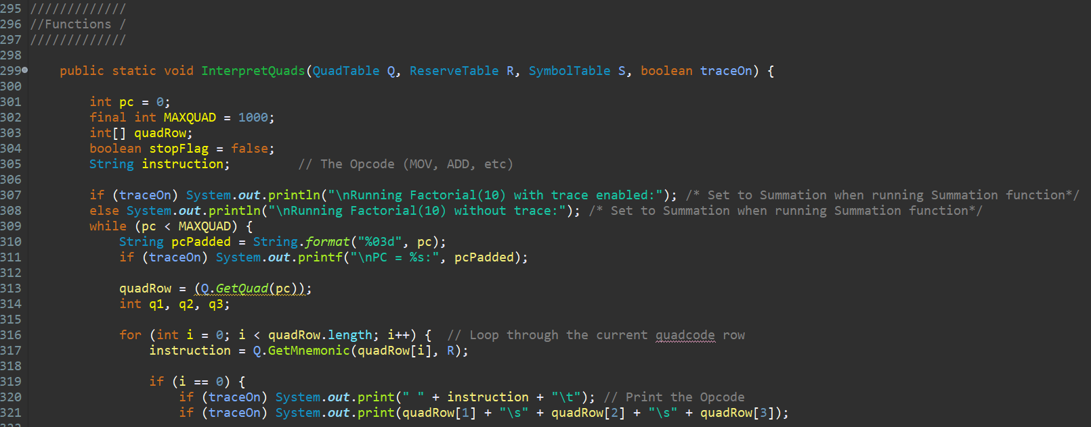

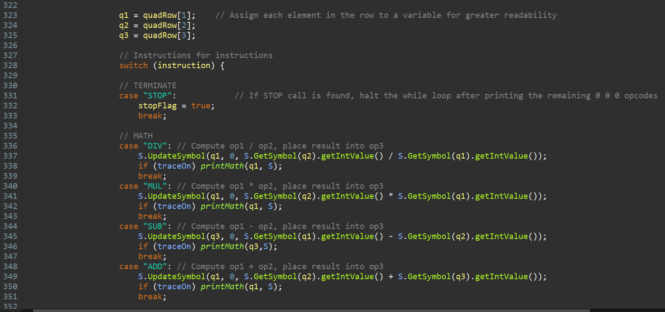

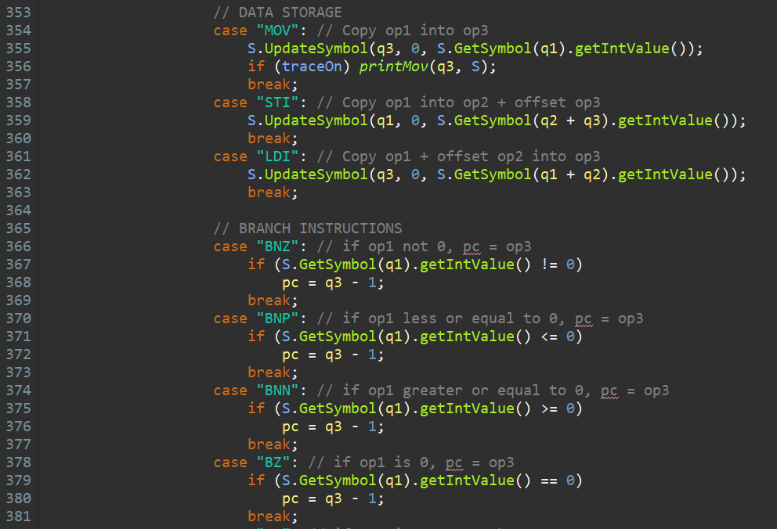

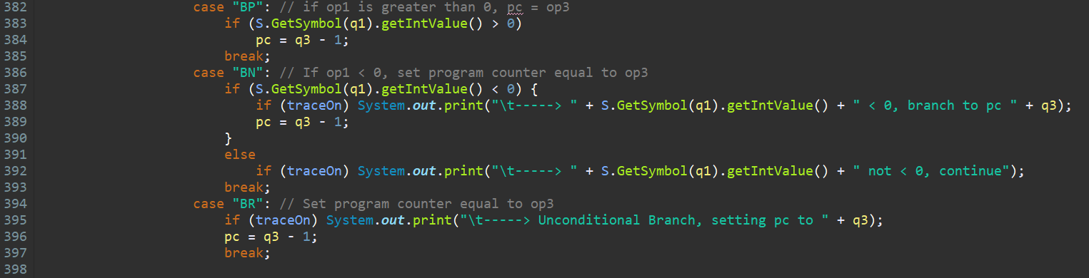

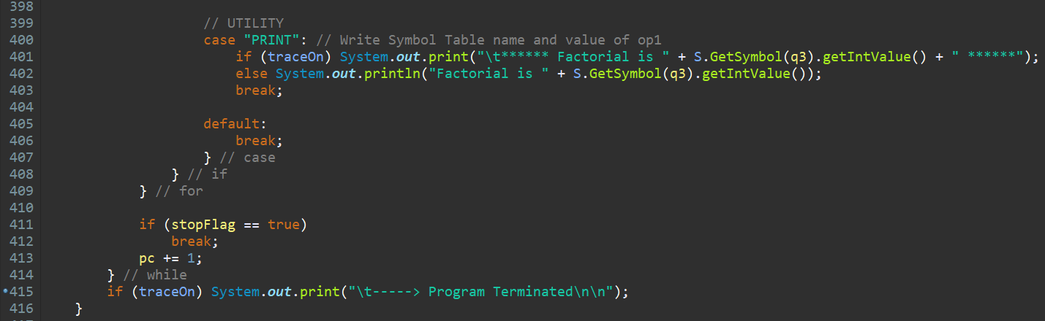

**Bu****ildQuads**

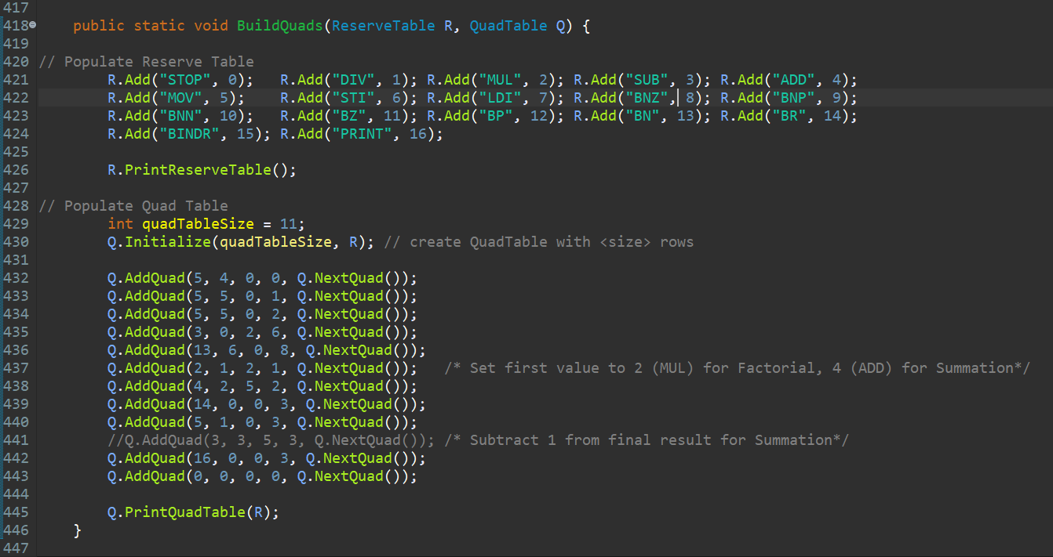

**BuildSymbo****lTable**

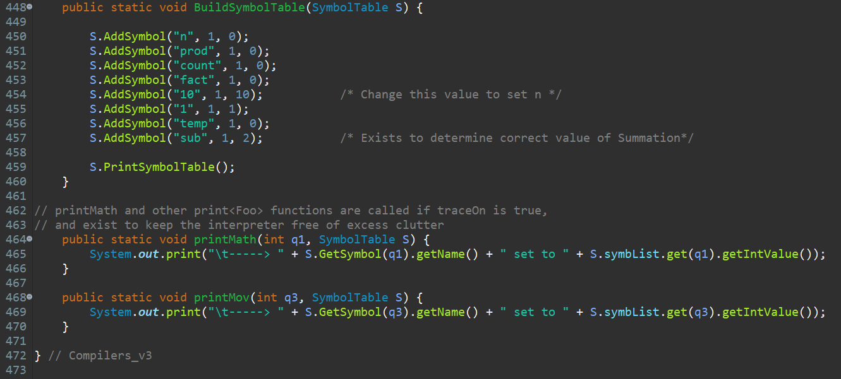

**Outp****ut**